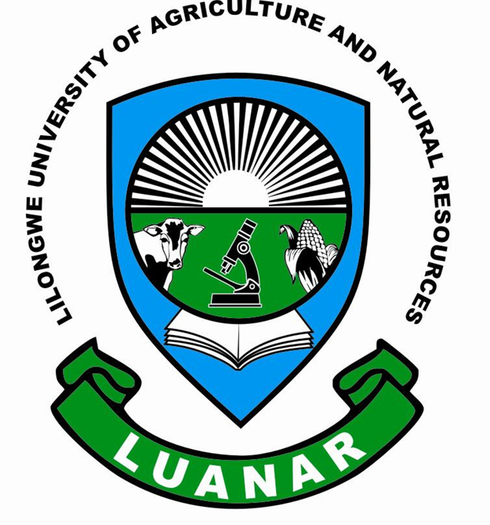

Knowledge Innovation Excellence

FACULTY OF FOOD AND HUMAN SCIENCES

INTERNAL ADVERT
TEMPORARY PROJECT COORDINATOR

Lilongwe University of Agriculture and Natural Resources (LUANAR) in collaboration with Department of Nutrition, HIV/AIDS (DNHA), Consumer Association of Malawi (CAMA), Ministry of Trade and Industry; Community Health Sciences Unit (CHSU) and Ministry of Health –Environmental health Unit are implementing an Irish Aid funded project which aims at contributing towards strengthening the capacity of Government institutions and other stakeholders to effectively implement the SUN: 1000 Special days using the NECS and strengthening the implementation of food fortification activities to combat micronutrient deficiencies in the country.

The project has the following components which are implemented by Ministry of Health (MoH) through; Community Health Services Unit (CHSU) & Environmental Health Services (EHS), Department of Nutrition, HIV/AIDS (DNHA), Ministry of Industry & Trade (MoIT), and Consumers Association of Malawi (CAMA):

- SUN: 1000 Special Days’ capacity building.
- Monitoring of fortified foods
- Consumer awareness on fortified foods.
- Enhancement of small/medium scale food processors’ capacity to effectively fortify their food products.

The Faculty of Food and Human Sciences at LAUANAR is looking for a motivated and qualified person to fill a vacant position of Temporary Project Coordinator. The person will support the implementation of Irish Aid funded project on “Capacity building for SUN: 1000 Special Days and food fortification in Malawi project”. The position is a temporary three month appointment.

The person will be responsible for:
- Overall coordination and reporting of the SUN-capacity building and food fortification in Malawi project.
- Collaborate with partners like Department of Nutrition HIV and AIDS (DNHA), Community Health Services Unit (CHSU), Environmental Health Services (EHS) CAMA, Ministry of Industry and Trade (MoIT) and National Fortification Alliance (NFA) in implementing activities of the project which include:

- SUN: 1000 Special Days’ capacity building.
- Monitoring of fortified foods
- Consumer awareness on fortified foods
- Enhancement of small/medium scale food processors’ capacity to effectively fortify their food products

- Ensure timely and quality activity implementation for project partners and LUANAR.
- Receive technical activity reports from partners and provide feedback.
- Prepare technical project reports.
- Participate in government and donor meetings on behalf of the project.

Qualification required
- The minimum qualification for this post is Bachelor’s Degree in Nutrition and Food Science or related discipline.
- Good report writing skills
- Computer competency and fluency in the use of SPSS, Nutri-Survey, WHO-Anthro-Plus for data analysis.
- Fluency in both written and spoken English.
- Excellent facilitation skills

Individuals who meet the minimum requirements and are available to immediately should send the application and up to date Curriculum Vitae (CV) with three traceable referees before 17th February, 2016 to;

The Dean
Faculty of Food and Human Sciences
Lilongwe University of Agriculture and Natural Resources,
P.O. Box 219
Lilongwe,
Malawi
ffhs@bunda.luanar.mw

